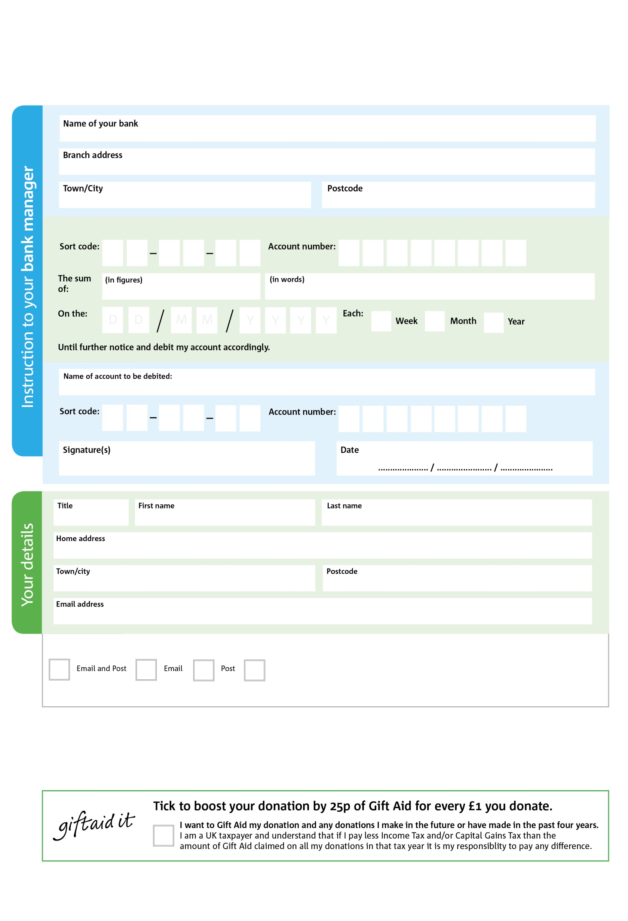

POSTAL ADDRESS: Wigtownshire Foodbank, 2 back rampart,, High Street, Stranraer, DG9 7LW

Reg. Charity No: xxxxxx | Reg. in England & Wales

X

V

X

V

X

V

X

V

X

V

X

V

X

V

X

V

**Please pass this form onto the foodbank, using the foodbank’s address at the bottom, who will save a copy for their records.   
They will then send it onto your named bank or building society.**

X

X

X

X

X

X

We would love to keep you up to date with information about XXXXXXX Foodbank. Please tick your preference:

You can change your preferences any time by contacting us on XXXXXXXX or emailing us at XXXXXX@XXXXX.XXX.XX

I do not wish to receive future communications from XXXX Foodbank

Please pay XXXXXXXX Foodbank,

**Data protection**

*Wigtownshire Foodbank is committed to protecting your privacy and will process your personal data in accordance with current Data Protection legislation. Wigtownshire Foodbank collects information to keep in touch with you and supply you with information relating to our work. To unsubscribe from our newsletter, send a message to the email address above with the word unsubscribe in the subject line. A full data privacy statement for financial donors is available from the foodbank on request.’*

**Standing Order Mandate**

**Wigtownshire.foodbank.org.uk**

You can change your preferences any time by contacting us on XXXXXXXXXXX or emailing us at XXXX@XXXXXXXXXX.foodbank.org.uk

I do not wish to receive future communications from XXXXXX Foodbank